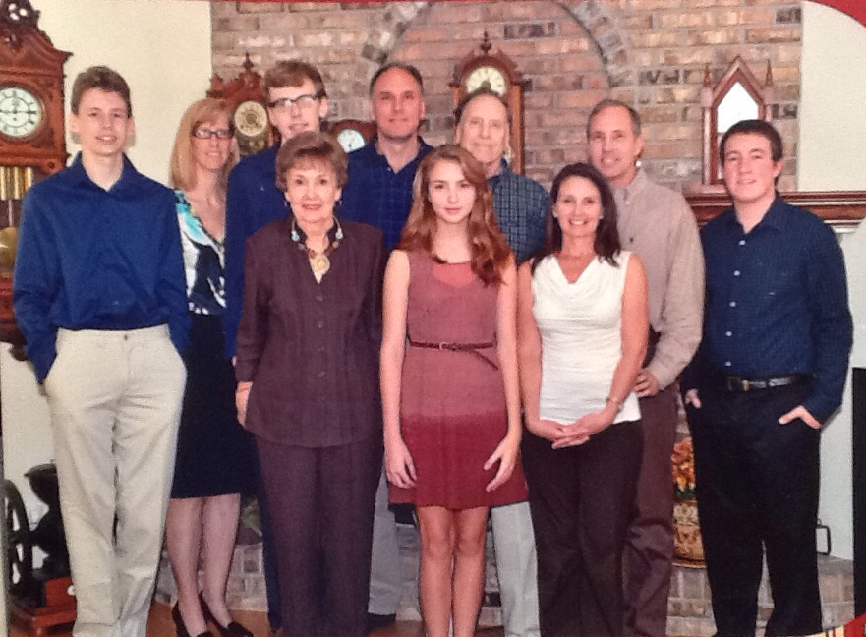

Philip and Margaret Wolfe family: (l-r) Cole (John Philip's son), Kimberly (John Philip's wife),  
Austin (John Philip's son), Margaret Wolfe, John Philip (Philip and Margaret's son),

Nicole (Aaron's daughter), Philip Wolfe, Lori (Aaron's second wife),

Aaron (Philip and Margaret's son), Connor (Aaron's son) – Thanksgiving 2012

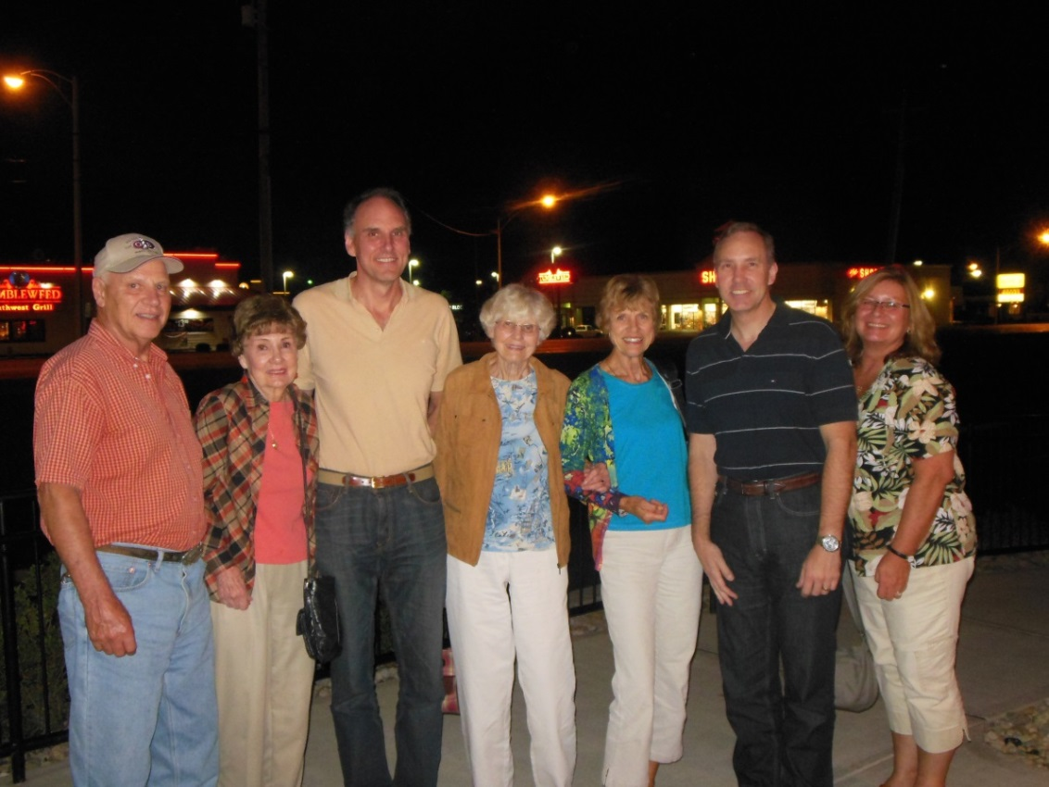

John, Marg, John Philip, Lois, Mary Jo, Aaron Russell, Tamey - 2013